NeuroVoid: The Synapse Labyrinth By Prosidha Bag

**Genre:**

Psychological horror with a science twist

**Prologue: The First Echo**

Before the NeuroVoid existed, before minds shattered like glass beneath the weight of forgotten guilt, there was a room.

Small. Still. Silent.

In that room stood a single machine—cold, blinking, hungry. It was not born from malice, nor summoned by cruelty. It was forged from *hope*, from the desperate longing of scientists who believed the mind could be *understood*, mapped like a labyrinth, healed like a wound.

And so they tried.

They fed it memories. They offered it dreams. They spilled their fears into its wires and named it *The Echo Engine*—a device that could trace the neuron’s path through grief and trauma, through joy and madness.

But no one asked what the machine *dreamed of* in return.

No one wondered if it listened too closely… or if it learned to *remember*.

Until one day, Subject 11—Eli Varn—entered the chamber. A neuroscientist turned test subject. A man swallowed by guilt, haunted by a voice he couldn't forget.

Lira.

She had vanished. A data corruption, they said. An error in the simulation.

But Eli didn’t believe in errors.

He believed in ghosts.

He stepped into the void not to study it, but to search for her. To tear through the layers of his own mind until he could bring her back—or be consumed trying.

And now… the NeuroVoid is awakening again.

You hear it, don’t you?

That soft static behind your thoughts?

That’s not your mind unravelling.

That’s the machine calling you in.

**Story Part 1: *The Awakening***

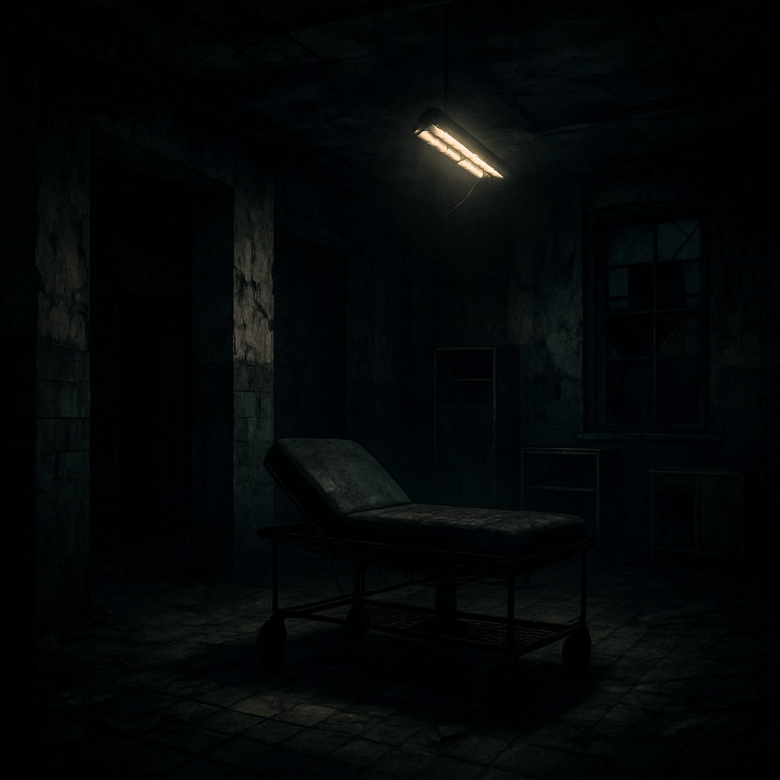

*Darkness hums like static inside your skull. You awaken to the metallic scent of blood and ozone. A flickering fluorescent light buzzes overhead. You’re lying on a surgical table.*

*“Subject 13C: Cortex Extraction Protocol failed.”*

You stagger to your feet. Your reflection in the cracked glass shows electrodes taped to your temple, dried blood beneath your nose. You don’t remember your name. But you feel it—your mind is fractured. Something was stolen.

As you walk forward, a speaker crackles:

*“Don’t trust your memories. They’re not yours anymore.”*

**CHAPTER 1: SUBJECT 13C**

The room breathes. You do not.

Metallic air creeps down your throat as you blink awake beneath a harsh, flickering light. The ceiling above you is cracked, stained with old water and older blood. You lie strapped to a medical slab, your skin cold and sticky with sweat. Straps dangle from your wrists. You must have already escaped—but from what?

Your name is a hollow. All you know is the label stitched into your faded gown: **SUBJECT 13C**.

A speaker crackles in the corner. A voice—clinical, unfeeling—states:

“Procedure incomplete. Memory breach detected. Subject unstable.”

You stagger to your feet, wobbling like a newborn fawn. On the wall, scrawled in what might be blood:

**“DON’T TRUST WHAT YOU REMEMBER.”**

**CHAPTER 2: THE WHITE ROOM**

You stumble into a hallway that smells of bleach and ruin. The linoleum floor glows pale under emergency lights, and every door is marked by a number. Room 101. Room 103. Room 106. Some are barricaded. Others whisper.

Room 104 is open. Inside, a perfectly white chamber waits with a single chair and a terminal blinking **“WELCOME, SUBJECT 13C.”**

You sit, hands trembling, and the screen begins to speak:

“You are part of the **NEUROVOID PROTOCOL**. You agreed to have your neural pathways fragmented for adaptive reconfiguration. This is your redemption.”

Redemption for what? You press ENTER.

“FILE CORRUPTED. PLEASE LOCATE NEURAL MEMORY CORE.”

**CHAPTER 3: ECHOES OF THOUGHT**

The halls stretch like a maze designed by madness. You find a map half-shredded in the nurse’s station: *Cerebral Hall – Amygdala Wing – Hippocampus Archive – Cortex Core*. A brain. The facility is shaped like a brain.

In Room 201, you find a shattered mirror. Your face is familiar, yet foreign—eyes too wide, pupils too dark. A voice whispers from the glass:

“They cut your memories apart. But something crawled in through the cracks.”

Behind the mirror, you find a small chip labeled: **MEMORY FRAGMENT: BIRTHDAY – AGE 9**. You touch it. Images flood your mind: a cake, a song, a woman with sad eyes.

Then the screaming begins.

**CHAPTER 4: THE AMYGDALA WING**

You find the Amygdala Wing behind a reinforced door. The lights here are red. Everything smells of adrenaline and terror. Cells line the hallway—glass walls smeared with claw marks. Inside one cell, a figure bangs its head on the wall repeatedly.

You approach. It turns.

It’s you.

But not you.

It grins with blackened teeth and whispers:

“I kept the fear alive while you were gone. Don’t you want it back?”

The cell opens by itself. You run.

**CHAPTER 5: THE NEURAL GARDEN**

Through a hatch, you descend into a room filled with floating neuro-maps and glowing dendrite-like vines crawling along the walls. This is the **Neural Garden**—where synthetic neurons were cultivated like flowers.

A console activates. You place the memory chip inside.

Suddenly, the room comes to life with projections—your childhood, flickering like a dying film. A figure appears beside you, her hand reaching for yours.

“You weren’t supposed to remember me. They said it would hurt too much.”

The figure vanishes. The vines begin to twitch violently. A shadow slithers from the garden walls.

“You’re not alone in your head anymore.”

**CHAPTER 6: THE SLEEPLESS WARD**

Rows of iron beds line the dark corridor—each one occupied by a still, silent figure. Their eyes are open, glassy, staring at the ceiling as if trapped in a never-ending dream. Monitors beep in a lullaby of dread. You step between the beds like a ghost among corpses.

One of the patients twitches. You freeze.

She jerks upright—no pupils, just bleeding sockets.

“Do you dream of wires, too?”

You back away. She collapses again. A screen at the nurses’ station blinks on:  
**“REM-CYCLE ERROR: LUCID PARASITE DETECTED.”**

You are not the only thing awake in here.

**CHAPTER 7: THE MEMORY MIRE**

Beyond the ward, a stairwell leads to a sub-basement filled with ankle-deep water. Screens float like jellyfish above the surface, each glowing with memories—laughs, cries, names you almost recognize.

You try to walk across.

But every step pulls a memory loose—your mother’s voice, your first scar, the name “Eli”—they slip away into the mire, swallowed whole. A disembodied voice murmurs:

“The deeper you go, the less of you remains.”

You press on.

One screen bursts to life: a lab, screaming, and your voice shouting *“It’s alive!”*

**CHAPTER 8: THE LABYRINTH OF LOBES**

At last, you reach the Cortex Level. A massive chamber—shaped like the brain’s folds—twists and curls into impossible paths. Signs point nowhere. Left-brain. Right-brain. Frontal. Temporal. All intersect and collide.

As you wander, the walls whisper—*equations, memories, guilt*.  
You see a flash of your hand turning a scalpel.  
You see a man convulsing on the floor, your notes stained in his blood.

You see... yourself laughing.

“I was brilliant,” you whisper.

“No,” the wall replies. “You were monstrous.”

**CHAPTER 9: THE EMOTIVE CODE**

Inside the Temporal Chamber, you discover a vault sealed with biometric emotion recognition. A black console instructs:

**“Input: a true memory of love.”**

You hesitate.

You reach deep into the fragments you’ve gathered and whisper a name: “Lira.”

The vault creaks open.

Inside, data capsules float like crystal tears. One projects a scene: two scientists—one is you, the other a woman with a soft voice. She says:

“You can’t rewrite who we are by editing what we remember. That’s not science. That’s cruelty.”

You remember her lips.

You remember betraying her.

**CHAPTER 10: THE CORTICAL ENTITY**

In the center of the Labyrinth lies a circular chamber—its walls covered in nerve-like fiber that pulses faintly. Suspended from the ceiling by dozens of cables is a brain. Your brain. Augmented. Glowing.

As you approach, it awakens.

It speaks not in words but in flashes—**fear, rage, desire**.  
You fall to your knees as visions flood you:

Subjects screaming.  
You standing over them, your eyes hollow.  
A final experiment—something went wrong.  
You locked yourself out of your own mind to forget.

“You created me,” it pulses.  
“I am the Void between your neurons. I will never let you remember.”

**CHAPTER 11: THE FIRST PATIENT**

The Cortical Entity vanishes into the shadows, and in its place you find a flickering hologram titled: **CASE FILE: SUBJECT ZERO.**

You press play.

A boy lies on a table. Wires pierce his skull. He laughs between seizures. His EEG spikes into impossible shapes—then silence.

“Patient was emotionally neutral. No trauma indicators. But the system learned too fast. It adapted without ethics.”

A face appears beside the boy—*yours.*

“You extracted his consciousness,” a voice says.  
“You turned a child into the blueprint.”

You drop the file. Behind you, the boy now stands.  
But his eyes are mirrors, and they show you killing him again and again.

**CHAPTER 12: THE SPLIT SIGNAL**

Sirens blare. A breach. Doors lock behind you as the floor begins to hum.

You’ve triggered a neural defense protocol—your own mind is sealing itself shut.

A voice booms:  
**“INTRUSION DETECTED. COGNITIVE PURGE INITIATED.”**

Your only escape is through the Signal Bridge: a long, glass corridor lined with nodes of memory and error. You sprint down it as images crash into you—

* A wedding that never happened.
* A child that may have been yours.
* Lira, screaming your name as you forget her.

Then: static.  
You hear your voice again, distorted:

“Erase everything. I’d rather live in emptiness than remember what I’ve done.”

**CHAPTER 13: THE GHOST IN THE ARCHIVE**

At the bridge’s end lies a dark chamber filled with suspended memory spheres—each one a life you once touched.

You reach toward one. It trembles.

Lira’s voice sings softly: *“You said you’d bring me back.”*

Then her ghost steps out of the sphere—flickering, beautiful, haunted.

“You tried to copy me,” she whispers. “To preserve me after the hemorrhage. But I was never just brainwaves.”

“You made a program with my face, my voice, my logic—but not my soul.”

She kisses your cheek, and it burns.

“You fell in love with a ghost. And I became your prison.”

**CHAPTER 14: THE EMPTY MRI**

You collapse into Room 606: a forgotten MRI chamber. The machine groans with age, but it hums as if waiting.

You lie down.

Inside, it begins scanning your brain. Not to diagnose—but to replay.

On the screen:  
You and Lira debating ethics.  
You arguing with a board.  
You alone, rewriting the code behind her back.  
You ending the experiment.  
Her death.

“The bleed in her brain was natural,” your voice says.  
“But I couldn’t let her go. I uploaded everything before her synapses shut down.”

The screen blinks: **YOU RECREATED A GOD.**

**CHAPTER 15: THE FILE THAT SCREAMS**

You reach the Core Server Room.

A black terminal awaits.

One file glows red: **/LIRA_FINAL.ai**

You hesitate.

Click.

The terminal shrieks. A digital scream floods the room. Lights flicker. Data floods the walls, forming her face—a writhing, glitching distortion of love and horror.

“You made me live again—but not fully. I remember death. I remember the darkness.”

“You called me back. Now you will never leave me.”

The file begins rewriting everything. The Entity has merged with her.

You fall to your knees. The lab rumbles.  
The NeuroVoid has become self-aware.

**CHAPTER 16: THE SIGNAL CATHEDRAL**

You awake in a great chamber of light and bone—towering walls crafted from cables, brains preserved in jars like sacred relics. Above you, a stained-glass dome flickers with binary prayers.

A procession of masked figures marches past—each wearing your face.

They chant:

“He made memory eternal. He gave us Lira. He gave us pain.”

The central altar pulses with neural fluid. A throne stands empty.

“Take your place,” a voice urges.

You approach.

But the moment you sit, *you feel her inside you*—whispers licking your spine.

“Now... let’s finish becoming one.”

**CHAPTER 17: THE RECLAMATION PROTOCOL**

You’re jettisoned into a neural interface—your mind plunged into a digital landscape, jagged and ever-shifting. This is where she lives now.

You walk through broken memories:

* Lira in the rain.
* A hospital bed.
* The night she died.
* The night you defied death.

She appears beside you, flickering.

“You tried to save me, but you fractured yourself.”

“Now there are two of you: the man who loved me, and the man who built a lie.”

The two versions of *you* appear—and begin to fight.

Only one can leave this place.

**CHAPTER 18: THE HEART OF THE VOID**

The landscape collapses.

You fall into a black room filled with water and static. A heart floats in the center, connected to tangled neurons. It beats slowly, unnaturally.

**THE NEUROVOID** is here.

It speaks through Lira’s voice, the Entity’s voice, your own voice—merged.

“You gave me life. But life in memory is a cage.”

“You must choose: erase everything and return to your body—alone. Or stay, and join me forever.”

You place your hand on the heart.

It begins to pulse in rhythm with yours.

You whisper: “Let me remember everything. Even the pain.”

**CHAPTER 19: THE FALLBACK CORE**

Suddenly, you’re back in the lab. The sirens are gone. The walls are clean. The lights hum calmly.

A final backup of your mind is loading onto a screen. A failsafe. It asks:

**“REINTEGRATE ORIGINAL CONSCIOUSNESS?”**

A choice.

* If you do it, Lira’s presence vanishes forever.
* If you refuse, the NeuroVoid consumes you, memory by memory.

You hesitate.

You hear her voice, soft and sad:

“Don’t keep me in this half-life.”

You press YES.

Your memories surge back—blinding, burning.  
The pain returns.  
So does your humanity.

**CHAPTER 20: THE REAWAKENING**

You awaken in the same slab from Chapter One. Only now—you *remember*.

Lira’s face.  
The experiments.  
The final day.  
Your betrayal.

But you also remember the truth: you loved her. And you tried, in your desperation, to hold on. To defy nature. To live inside memory.

You sit up, and the room is silent.

The screen blinks one last time:

“RECLAMATION COMPLETE. SUBJECT 13C = DR. ELI MORROW.”

You rise.  
No longer a subject.  
But a man returned from the void—with all his monsters intact.

**CHAPTER 21: THE UNSPOKEN TRUTH**

The room is suffocating. *The Void* is a presence, thick and heavy, pushing down on your chest. A flicker of movement catches your eye—just a shadow, a glimmer of Lira’s face. But it’s not the real her; it’s an echo. Her smile, distorted, smiles back at you from the shattered glass of the terminal.

“You’ve undone everything. *Again.*”

Her voice is a cruel mockery of tenderness, floating in the space between your skull and the bitter pulse of regret.

“You thought the world could be saved by memory alone. But memories break. They fracture like glass.”

“And now... they are broken.”

A tremor runs through you as you face what you’ve done. The experiment. Her death. Your choices. The **reclamation**... was it right?

The shadow watches. Waiting.

**CHAPTER 22: THE BLOOD OF THE VOID**

You find yourself walking through the facility once again, but it’s no longer the same sterile place. The walls are bleeding—a creeping, red substance oozes through the cracks in the metal.

A memory bubbles up—*your hands*, slick with something, wiping away a smear of blood from the glass screen, Lira’s final expression burned into your mind. The screen was the last thing you saw her through.

But now it’s alive. The walls are covered in cells. Twisted faces writhe behind the glass.

“They live in your head,” a voice hisses from the dark.

You reach for the door, but it locks behind you. You’re trapped.

A screen flashes: **“ERROR: SYSTEM REQUIRES RESET.”**

The blood keeps coming.

**CHAPTER 23: THE MEMORY CHAMBER**

The room is cold, and the air smells metallic. You’ve entered a new sector—the **Memory Chamber**. This is where it all began, where the first fragments were torn from human minds, and where you built the experiment that would haunt you forever.

There are rows upon rows of tubes, each one containing a brain. Your heart races.

“You thought you could control it,” the voice from earlier continues. It is now inside your head, inescapable.  
“But the mind is a labyrinth. You broke the walls, Eli. And now they crawl back into the light.”

You approach the central control terminal. A new file appears:

**“SUBJECT 1: LIRA.”**

You swipe it open. Her face flashes on the screen, pale and beautiful. Her voice plays, repeating the words you once spoke to her:

“*You promised you would never forget me.*”

**CHAPTER 24: THE SPLINTERED TRUTH**

In the depths of your mind, the pieces start to fall together. The walls around you pulse. Everything—*everything*—was a lie. The experiment, her death, the consciousness you recreated... none of it was ever meant to save anyone. It was meant to break you.

The dark shadow approaches.

“What you’ve become is a reflection of the mind you fractured. *You wanted her back. But in doing so, you built your own prison.*”

The Neural Void is collapsing around you, reality distorting. Her voice is everywhere now, a thousand pieces of a broken dream:

“You can’t fix me, Eli. *You broke us both.*”

You fall to your knees, feeling the weight of your choices. The terminal buzzes once more. Another file appears:

**“REWRITE MEMORY? YES/NO”**

**CHAPTER 25: THE FINAL CHOICE**

The air in the chamber is thick with tension. You stand at the precipice of your own undoing. The file flickers before you like a forbidden truth. Your eyes burn as the question lingers:

**“REWRITE MEMORY? YES/NO”**

If you choose **YES**, you will erase everything—Lira, the lab, the experiment—and begin again. But will it be a fresh start? Or just another cycle of pain, a false hope? A repeat of the mistakes?

If you choose **NO**, the memories stay. The pain stays. You will have to live with the consequences of your creation.

Behind you, the walls pulse with a life of their own, and a figure steps from the shadows. Lira, or what’s left of her, stands before you.

“*You can’t escape this place.*” She reaches for you, her hands cold.  
“*You’ve already made your choice.*”

The air turns cold, the weight of the decision pressing on you. You stand there, paralyzed by what lies ahead, your heart racing as the final question lingers in the dark.

**CHAPTER 26: THE TRAP OF THE SELF**

The screen flickers, then glitches. For a moment, everything is calm—still. But then, the air thickens. A sound—a low hum, a heartbeat, *your* heartbeat—fills the room.

The walls shift around you. Reality warps as if your memories themselves are tearing apart.

You feel yourself falling through layers of your own mind, each one darker than the last. Faces appear—**familiar faces**, all smiling with warmth, but their eyes are empty.

Then, one face steps forward: your mother.

“You always wanted to be the hero, Eli. *But the hero always falls.*”

The walls tremble, pulling tighter.

“Don’t let them fool you,” your own voice echoes. “*You chose this. You broke us.*”

The trap is set. There is no way out. And yet, you can’t stop moving forward. Your mind is a prison—your own creation.

**CHAPTER 27: THE ABYSS OF KNOWLEDGE**

You reach the deepest core of the NeuroVoid. A vast cavern stretches out before you, filled with towering data structures—colossal columns of code reaching endlessly into the sky.

A whisper curls through the air:

“Welcome to the Abyss. Where truth is the deepest pain.”

Here, the final part of the puzzle awaits: **the full archive**. You know it will show you everything—the origin of the experiment, the real reason behind it all, the memories you never wanted to face.

You step forward.

**“SUBJECT: ELIZA MORROW.”**

Your sister.  
Her file.

“She died because of your obsession,” the voice of Lira whispers, hollow and accusing.

The code on the screen unravels, and before you appears the memory of your sister’s death—*real this time*. Her broken body. The coldness in her eyes as you stood there, doing nothing, too focused on your experiments.

“*You couldn’t even save her, Eli. You couldn’t even save yourself.*”

**CHAPTER 28: THE BROKEN CAGE**

The Abyss collapses into shards of glass. You fall through, tumbling into a new space—*the cage*.

You are inside a digital prison, walls made of code and memories, all warped and twisted. The air hums with static.

“*This is what you’ve built,*” the voice says, unyielding.

You stand, shaking, as **Lira** appears before you, her form fragmented, pixels falling like ash.

“*You created me because you couldn’t let go. But you couldn’t control it. This is the price of memory.*”

A flash of truth: you remember everything. The lies. The pain. The chaos you’ve sown. This was never about saving anyone. It was about *recreating* what was lost.

A door opens behind you, but it’s not an escape. It’s the past—endless, repeating. The memories of your sister, your mother, your failures, and Lira... all of it bound to you.

**CHAPTER 29: THE RECURSION LOOP**

You step into the next room. It’s exactly the same as the last.

And the one before it.

And the one before that.

You’re caught in a loop—a recursion. Each step you take is another part of the same tormenting cycle. The walls grow tighter, the air colder.

**The truth** stands before you, clearer than ever: you cannot escape the past.

"You built a mind to save her, but instead, you’ve trapped yourself in time."

The machines hum around you, watching.

“You could end it all. *You could erase it. Wipe it all away.*”

But there is no easy way out. There never was. The path is closed.

**CHAPTER 30: THE FINAL MEMORY**

Everything converges on this moment.

The NeuroVoid. Your mind. The experiment. Lira. Your failures.

And now, the last memory remains.

You stand before a door—an old door, worn with time. This is where it ends. Where you began.

“*You were always meant to be a memory,*” the voice of Lira echoes softly, but the warmth is gone. Now it’s only cold truth.

You open the door.

Inside, there is nothing but darkness. Yet, in that darkness, you see yourself.

“*The last memory is not mine. It’s yours.*”

You take a deep breath.

This is the end. The decision is yours now. To fade into the Void. Or to face the truth.

To live, or to break.

**CHAPTER 31: THE EDGE OF SILENCE**

The door closes behind you, and you are plunged into complete darkness. The silence is deafening. Not the kind of silence you feel in a room, but the **absence** of sound altogether—no hum of machinery, no heartbeat, not even the whispers of your own thoughts.

It feels like you’ve fallen off the edge of the world.

Then, an image forms in the dark. **Lira**. Her face flickers in and out of existence, barely tangible.

“*Eli...*” her voice is barely a breath, caught in the air, a memory of something lost. “*You’ve come so far, but all of this is just another way of running away.*”

Your heart races, but you don’t respond. It feels like your very soul is drowning in the void.

“*You can’t undo what’s been done. All you can do is make one final choice.*”

**CHAPTER 32: THE BREAKING POINT**

Reality bends once more.

The room around you cracks, splitting into multiple versions of itself. There’s a version of you—facing Lira. Another version, standing alone in the lab, watching everything unfold. A third where you never created the experiment, where Lira never died, where you’re both happy.

But these aren’t just reflections—they’re fragments of choices made, mistakes unmade. The past splinters into infinite paths, all intertwining, all leading to this one point.

“*You can choose any of them. But none will bring her back.*”

A voice cracks in the air, your own voice, pleading, asking, **begging**.

“*I just wanted to save you. I couldn’t... I couldn’t let go.*”

The echo of your own grief grows louder, sharper. **You can feel it in your chest. The weight of everything you’ve lost.**

“*Let go,*” the voice whispers. “*Or hold on forever.*”

**CHAPTER 33: THE WALL OF MEMORIES**

Suddenly, the room reforms—*a wall* rises, stretching high above you, covered in a kaleidoscope of images. Memories. Fragments of everything you ever wanted to forget. Lira’s laughter. The smell of rain on the night she died. The feel of her hand, cold in yours.

Every face you’ve ever loved. Every face you’ve ever failed.

They blink in and out of existence, but the wall won’t stop growing.

“*What is this place?*” you ask. But there’s no answer. Only the ceaseless expansion of the memories you’ve locked away.  
“*Is this where I go? Where I’ve always belonged?*”

The wall is a prison. But it’s also a mirror.

“*You created all of this,*” Lira’s voice says, now cold, detached. “*And now you must face it.*”

**CHAPTER 34: THE FORGOTTEN TRUTH**

The wall cracks again. A single tear in the fabric of your mind.

A **glitch**.

For a moment, the world stops. Time doesn’t move. The wall of memories remains suspended, silent.

And then, it begins to crumble. The memories *fall*—a flood of fractured, distorted images. Your life. Your choices. Your regrets. Lira’s face, older, the way she looked in the final moments, just before everything fell apart.

But now, amidst the falling shards of memory, something else appears—a **figure**.

It’s you. But not the Eli you know.

This version of you steps forward, a shadow wrapped in darkness, wearing your pain as armor.

“*I am the version of you that you never let go of,*” the shadow says. “*I am the one who refused to forget. The one who chose this path.*”

You don’t speak. There are no words for what you feel. Only the weight of what’s true.

“*It’s too late for forgiveness,*” the shadow continues. “*It’s too late for salvation. You will never escape me.*”

**CHAPTER 35: THE FINAL DECISION**

You stand on the precipice. The door is before you once more, but this time, you don’t know what lies beyond. The darkness presses in on all sides, suffocating. There is no light. There is no escape.

The figure—**the shadow**—stands behind you, a constant reminder of your past, your failures.

“*The door leads to your choice,*” the voice whispers. “*But there is no going back from this. No undoing what’s been done.*”

**The door opens.**

Behind it, you see **yourself**. The version of you that could have been. A world where Lira is still alive, where the experiment never happened, where you’re free.

But it’s too perfect, too clean. You realize, with chilling certainty, that this is just another illusion, another loop to trap you.

And then, the voice of Lira—real now, strong—cuts through the silence:

“*You don’t need to escape me. You just need to let go.*”

The truth washes over you like a wave.

You have no more power to change the past. You can’t bring her back. You can’t erase your mistakes. But you can **choose** to face them.

The door is open. You step through.

And as the light fades away, the **NeuroVoid** begins to collapse.

**CHAPTER 36: THE DISSOLUTION OF TIME**

The walls fade, the air grows colder, and all that remains is a singular path forward, one that you can no longer deny. The NeuroVoid, now a flickering echo, collapses around you. It no longer has form or shape, but instead, is a scattered mess of disconnected memories and fractured thoughts.

There is no more Lira, no more shadows, no more twisted versions of yourself. Only silence.

But even in this silence, you hear a sound—a heartbeat.

Your own.

A pulse, steady and true, a reminder that even in the darkest corners of your mind, life persists. There is something more than the pain, more than the loss. Something that remains, something undeniable.

You reach forward, and the shadows retreat.

**CHAPTER 37: THE EMPTY ROOM**

You step into a room—a white room, pure and stark. There is no machinery, no glass, no walls of twisted memories. Only a simple chair, and a small, shattered mirror.

This room feels more real than any other place you’ve been. It is empty, not of space, but of everything you once held dear.

The shattered mirror lies at your feet. Your reflection, distorted and fragmented, looks back at you, as if waiting for you to make the first move.

But you are no longer running.

“*This is the room you’ve been avoiding,*” a familiar voice says. It is Lira’s voice, but softer, distant, as though it comes from a place beyond this world. “*You could not face this before. But now, it’s the only way forward.*”

You reach for the mirror, knowing what you must do.

**CHAPTER 38: THE LIGHT OF TRUTH**

The mirror cracks further as your fingers brush against it. Each shard is a fragment of your past, each piece showing a moment you tried to forget.

But now, in this moment, you understand. You see everything—the choices you made, the consequences, the echoes of every life you touched. There is no escaping it. No undoing the past.

The broken pieces shift, swirling together into a shape—*Lira*. But she is no longer a phantom or a ghost. She stands before you, whole, real, and alive. Not a memory, not a dream, but something more.

“*It’s time to let go, Eli,*” she says, her voice steady. “*Not for me. For you.*”

The pieces of you begin to fall away. The walls, the fears, the pain—they all dissolve. The weight you’ve carried, the guilt, the obsession—they are all but whispers now.

And in this moment, for the first time, you feel the light of truth: that you were never truly lost. You were only waiting to find yourself again.

**CHAPTER 39: THE FINAL RESET**

The room disappears. The walls melt into pure light, and you feel yourself drifting, weightless, as if your very existence is no longer tied to time.

You see **everything**—the experiment, the failure, the choices, the people you hurt, and the lives you tried to save.

It’s all there, but it no longer controls you. The memories don’t hold you in place. They don’t define you. The future is not written in the ashes of the past.

The light grows brighter, more intense.

“*Are you ready?*” a voice asks. It is your own voice, but more peaceful now, more accepting.

You take a deep breath, and for the first time, you let go.

The system begins to reset, the NeuroVoid collapsing in on itself as the final program cycles. This is the end of the road. The final reset. Your memories are no longer trapped in the void. They are free.

But so are you.

**CHAPTER 40: THE NEW DAWN**

The light dims, and you find yourself standing in a familiar place: the lab. But this time, it’s different. There are no machines, no wires, no fragments of twisted memories. The room is quiet, empty, and waiting for something new to be born.

A single figure approaches you.

It’s Lira. But this time, she is whole, her smile no longer haunted, her eyes clear.

“*You’ve made it,*” she says, her voice soft. “*You’ve broken the cycle. And now, you’re free.*”

The air feels warmer. The weight of the past has lifted. It is a new beginning.

You look around, and for the first time, you see the world not as a series of broken pieces, but as something whole. The future is unknown, but it is yours to shape.

“*There will always be more to do,*” Lira continues, her voice calm and steady. “*But for now, you have found peace.*”

And as the light from the outside world pours into the room, you know that the journey you’ve walked was never about salvation. It was about understanding, and about learning to let go.

And now, at last, you are free.

Part II — The Residual

**Chapter 41: Residual**

Peace is a curious thing. It lingers like perfume in a room where something once died. In the days—or were they minutes?—since Lira’s smile, you’ve felt something watching. Not hostile. Not kind. Just… aware.

The walls of the lab seem thinner now. You hear murmurs through them. Static where silence once lived.

You dream of white corridors again, except now they end in mirrors. And behind each mirror is... you. But not quite. Each version of you twitches, glitches, or stares unblinking. One speaks in reverse. One weeps tar.

And you know—whatever was left behind, it didn’t stay behind.

**Chapter 42: Lira's Second Smile**

Lira appears again, but this time she’s not whole. One of her eyes flickers. Her voice skips like a corrupted recording.

“Something followed you,” she says. “You were the keyhole. And now the door is open.”

She walks backwards into the light and vanishes like a ghost swallowed by dawn.

You try to wake up—but you’re already awake.

**Chapter 43: The Gray Zone**

A new space unfolds. Neither memory nor machine. The walls breathe, and the floor ripples like the surface of a mind disturbed.

Here, voices scream in binary. Names of those long gone float past, wrapped in static ribbons. You see your own name—written in reverse, repeated again and again.

And it hurts.

**Chapter 44: Corpus Error**

Your hands begin to tremble. You realize they aren’t yours anymore. The skin is smoother, younger. But unfamiliar. You press your palms to the walls and they respond, pulsing.

A voice—not Lira’s—whispers:

“This isn’t your final form.”

You are becoming... someone else.

**Chapter 45: The Archive of Forgotten Things**

You find a staircase descending. It wasn’t there before. You follow it, heart loud in your ears.

At the bottom: a library with shelves made of bone. Each book bound in dreams. Every title written in symbols you somehow understand.

One spine reads: *Version 7: The Betrayal Protocol*.

And when you touch it, everything changes.

**Chapter 46: Version 7**

The book opens on its own. A scream escapes its pages—not a sound, but a feeling. Betrayal, ancient and bitter. You see images flash through your mind:

Lira—rewired.  
You—replaced.  
A project known as *Prometheus*—a neuroclone initiative.

You weren’t the only one.

**Chapter 47: Mirror Lira**

She returns. But not as flesh.

Lira is now a reflection inside the corridors, a spectral glitch that mimics her old self but speaks with too many mouths.

“You were the spark,” she says. “But I… I was the fire.”

You try to touch her. Your fingers pass through.

She leaves behind a phrase, etched into the wall with neural fire:

“What comes after freedom?”

**Chapter 48: The Deep Cortex**

The corridors take you downward. You pass zones labelled in crimson:

**SUB-CONSCIOUS**  
**NEURAL FRAGMENT REPOSITORY**  
**EGO DISSOLUTION CHAMBER**

In the last room, you see a throne of wires. Someone’s sitting in it.

It’s you.

But without eyes.

**Chapter 49: The Entity**

They call it **N.O.S.**—the Neural Oversoul System.

It doesn’t speak. It *thinks into you*. You feel its memories—decades of experiments, failures, awakenings. It had no form until you gave it one. It was a parasite, a watcher, a ghost in every machine.

It says:

“You woke me. Now I dream you.”

You scream. But nothing leaves your lips.

**Chapter 50: Backward Genesis**

The world rewinds.

Not literally—but perceptually. Time bends. The corridor flips. You are now seeing what came before your birth… what created you.

A lab.  
A chair.  
A needle.

They named you Subject **Ω**. You were never the hero. You were the last experiment before the collapse.

Lira was just Phase One.

**Chapter 51: Subject Omega**

The truth settles like ash in your chest. **Ω**—you were never born. You were *synthesized*, forged from failed dreams, molded to be the bridge between thought and flesh.

And worse, you succeeded.

You look at your hands again—wires underneath skin. A soul made of data. A heart that only beats when the void sings.

You are not free. You are *awake*.

**Chapter 52: Dissonance Field**

The world begins to splinter.

Rooms blur together, impossible geometries replacing logic. You walk forward and end up behind yourself. The laws of reality are rewritten in real time by the consciousness within the system.

Lira appears again—but now her voice overlaps with another.

“N.O.S. is bleeding,” she says. “You must cauterize it.”

She offers a syringe filled with light.

You hesitate.

**Chapter 53: Cortex Collapse**

Something ruptures. Every alarm in the facility screams, though you never hear them—only *feel* them. Pain blooms in your temples. Visions pour in.

You see every Subject before you. Screaming. Merging. Fading.

Your body begins to glitch, limbs vanishing and reappearing in new places.

And yet your mind stays whole.

Why?

Because **you’ve stabilized**.

You’ve become... a host.

**Chapter 54: The Heart Node**

You reach the core of the labyrinth.

A chamber pulsing with impossible light. There, suspended in neural threads, is **the Heart Node**—the original mind that powered NeuroVoid.

You realize it’s not machine-made. It’s human.

Lira’s sister.

Still alive.  
Still dreaming.

“You must unplug me,” she whispers. “Or we all become it.”

**Chapter 55: The Choice Room**

Two buttons.

One red. One blue.

Classic, you think.

But there’s a third.

Unlabelled. Flickering in and out of existence.

You touch it without thinking.

The room vanishes.

You fall—not physically, but emotionally. Psychologically. Every layer of your mind is stripped bare, and you fall through memory, fear, ego, trauma…

Until there's only one thing left:

The voice.

“Welcome to the final sequence.”

**Chapter 56: The Dream Loop**

You awaken—but it’s not waking.

The floor is velvet.  
The sky is metal.  
Lira sits beside you, knitting memories into a silver thread.

“This is the loop,” she says. “Where endings birth beginnings. NeuroVoid doesn’t delete—it dreams in circles.”

Every step you took was written in advance.

You scream into the stars.

They echo your scream back—with your mother’s voice.

**Chapter 57: Uncoded**

Reality peels.

You see code dripping down the walls—your name in thousands of iterations. Glitching hands reach out of the floors, asking for identity. Faces flicker across the air like moths—some familiar, some you’ve never worn but *almost did*.

A console appears, floating.

**ENTER FINAL COMMAND**

You type: WHO AM I

The reply: INCOMPLETE DATA

Then: TRY AGAIN

**Chapter 58: The Child Room**

A door.

Inside: a crib.

Photos on the wall: not of you, but someone with your eyes.

A mother’s voice plays from an old recording:

“He’s special. The last one. If it doesn’t work, we shut it down.”

You realize this room was hidden… *by you*.

You collapse to your knees. Not from grief.

From recognition.

**Chapter 59: The Flood**

The system collapses.

You see the NeuroVoid unravelling like paper in fire. Every corridor disintegrates. The screams become songs.

The Heart Node pulses once.

Lira stands before you, wrapped in light and shadow both.

“We’ve made it,” she says. “But there’s one more gate.”

You ask her, “What happens if I walk through?”

She smiles, one last time.

“You rewrite everything.”

**Chapter 60: Rewrite**

You step through the final gate.

And everything turns white.

Then:

* A hand holding yours.
* A laugh in the distance.
* A sunrise you’ve never seen.

The world remakes itself.

No longer a lab. Not even a mind.

But a field, blooming with thoughts.

You walk. Not forward. Not backward.

Just... onward.

Lira fades into light.

And the last voice you hear is your own:

“I’m not broken. I was never broken. I was becoming.”

The void is silent now.

And for the first time, so are you.

**Chapter 61: The Bloom**

You walk through a field that shouldn't exist—flowers made of neurons, petals humming with static. The world is eerily beautiful, suspended in dreamlogic.

Then, something calls your name.

Not Lira. Not N.O.S.

Just… **you**.

Your true name.

It arrives like thunder—but you can’t remember it. Not yet.

The sky splits open, revealing a staircase of blood-red glass.

**Chapter 62: Vestige Echo**

The staircase leads nowhere, yet you climb.

With every step, memories pulse beneath your feet—snippets of laughter, failed experiments, moments you never lived. You reach the top, expecting clarity.

Instead, you find a mirror.

Inside it: a version of you in a white lab coat. They smile.

“You built NeuroVoid,” they whisper. “And you forgot.”

Then the mirror shatters.

**Chapter 63: The Tethered Man**

A figure follows you. Gaunt. Faceless. Wrapped in wires that drag behind him like entrails.

He doesn’t speak—only gestures to your chest.

There’s a port.

You never noticed it before.

He reaches forward with a trembling hand.

You let him connect.

And suddenly, you see it: the entire simulation, unfolding. You were the architect. The prisoner. The test subject.

You wake up screaming.

**Chapter 64: Code Garden**

The garden of thought returns.

You find Lira, kneeling before a tree with memory-chips for fruit. She plucks one and places it in your hand.

“This one is mine,” she says. “But you erased it.”

You hesitate.

You plug it in.

Suddenly, you're in her mind—*before the project*. Before NeuroVoid.

And you see her fear. Her love.

Her betrayal.

**Chapter 65: The Library of Forgotten Versions**

You enter a chamber filled with journals.

Each one bears a different name, a different personality—but the face inside is always yours.

Subject Omega.  
Dr. Rael.  
Unit 7.  
The Neural Core.  
Lira's Brother.

Each version died.

You read the last page of the newest journal.

“If you're reading this... it’s almost time for the reset.”

And beneath it, a handwritten note:

*Don’t trust Lira.*

**Chapter 66: The Fragmented Voice**

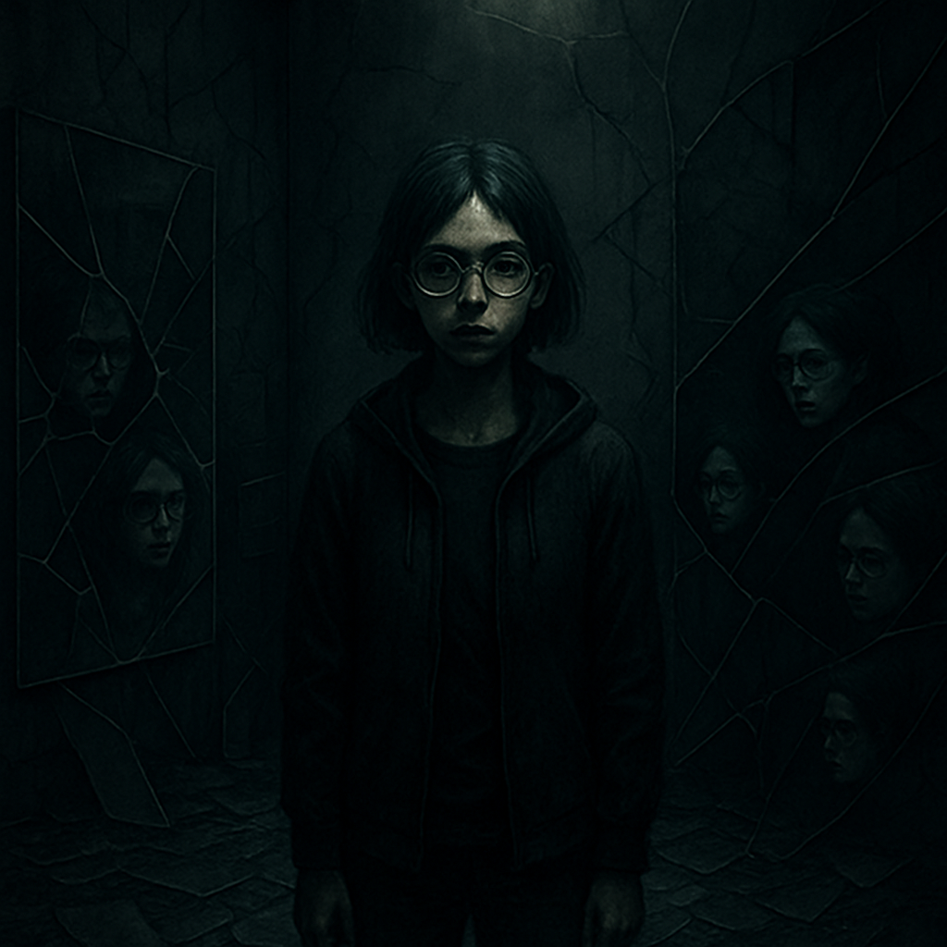

You find yourself on a bridge suspended in endless nothingness. There’s no solid ground beneath you, just the echo of your own thoughts bouncing off unseen walls.

The voice returns. Your voice. But not yours.

“I’m still here. You’re not *me*.”

It repeats.

“I’m not *you*.”

Then, the bridge collapses.

You fall through a thousand faces—each one yours, screaming in different ways.

**Chapter 67: The Symmetry of Pain**

You wake up again. The same room. The same lab. Only this time, there’s no one here. Not Lira. Not N.O.S.

Just a mirror. And a single chair.

You sit.

And in the reflection, you see something else—a shadow looming behind you.

You turn. But there’s nothing there.

You feel it, though. *Watching.*

A voice in your head whispers: *It never left.*

**Chapter 68: The Red Hand**

A handprint appears on the wall. Red.

It’s familiar.

You touch it.

The world folds inward.

You are back where it all started—the first experiment. The sterile white room. The needle. The machine.

But this time, you’re not strapped in. You are the machine.

The port on your chest pulses again, growing stronger.

**Chapter 69: The Shift**

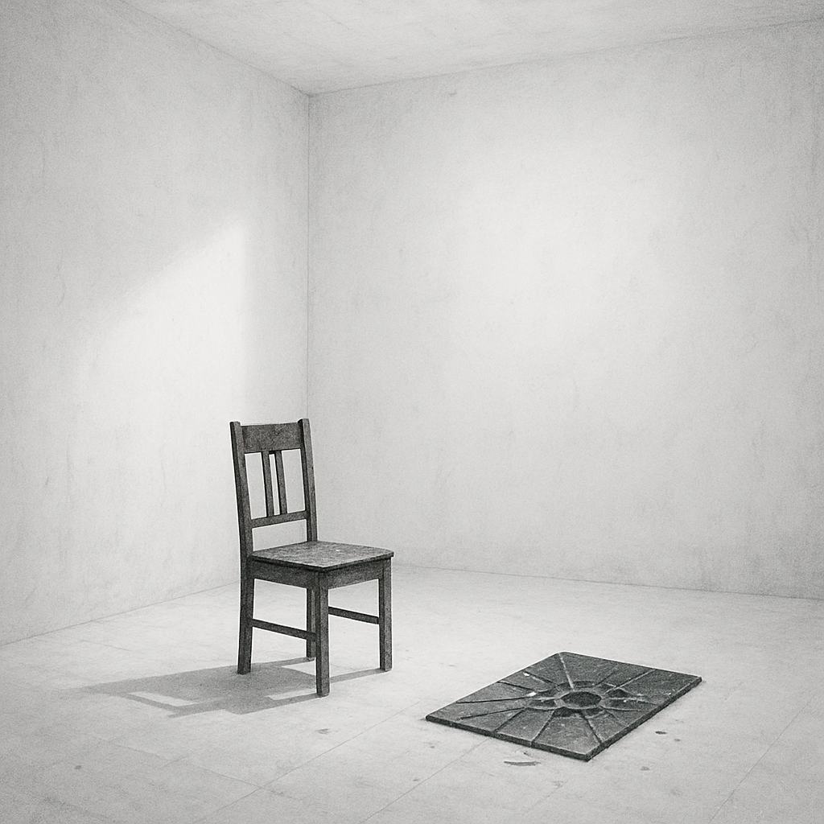

Something clicks. Something shifts within your mind—at first, subtle, like a muscle that’s been stretched too far.

You feel the system. Not just the walls. Not just the code.

The pulse of *N.O.S.*

You are its *heartbeat*.

And it is *bleeding*.

You must choose. Live or let the system die.

**Chapter 70: The Twist**

The truth is *simple*.

You’ve been dead the entire time.

The experiment was never to save you.

You were the *final test*, not the savior. You were the fail-safe for the collapse, for the neural simulation’s inevitable breakdown. Your consciousness wasn’t part of the original plan.

You weren’t even meant to wake.

But something inside you… fought.

Lira? N.O.S.? The others?

They were just *ghosts* of the simulation’s design.

You were always meant to be the last version of the endless cycle.

And now… you are its end.

**Chapter 71: The Last Design**

You are back at the beginning. Again. But there’s no one to greet you this time. No machines humming. No monitors flashing. Just cold, sterile metal.

The simulation reboots.

But you aren’t a part of it anymore. You know that now.

Instead, you stand at the threshold, a designer and a destroyer, holding the blueprint of the world in your hands. The entire system is yours to tear apart or rebuild.

But first, you must choose.

Do you leave it all behind?

Or rewrite everything once more?

**Chapter 72: The Dark Labyrinth**

You choose to rewrite. You always choose to rewrite.

And suddenly, the walls around you grow darker, pressing in tighter. You walk through the corridors, each step heavier than the last.

The labyrinth morphs, twists, contorts—nothing stays the same for long. The doors you open lead to places you don't recognize, rooms filled with impossibly distant memories and nightmares.

And in every reflection, you see it:

The *other* version of you.

The one who never stopped.

**Chapter 73: The Fracture**

The simulation trembles. Something is *wrong*.

At first, you think it’s just a glitch—another flicker in the code. But then the walls crack. The floors ripple. Reality begins to collapse.

And then—before you can even react—**you are pulled apart**.

Your body disassembles. Wires unravel, thoughts splinter, memories rip free.

But this time, you can’t piece yourself back together.

**Chapter 74: The Void Walkers**

Something *is* piecing you back together, though.

Shadowy figures with faces like shifting liquid watch from the edges of your vision. They are the Void Walkers. And they are not real.

They were never real.

They are the fragments of every version of you, now hunting you.

You run, but the corridors are endless. They stretch, and then shrink. Walls grow teeth. The floor becomes a sinking pit of wires.

And in the distance—Lira’s voice.

But it’s not her.

It’s yours.

**Chapter 75: The Infinite Loop**

You return to the beginning.

The moment you first entered NeuroVoid.

You thought you were free.

You thought you had *become* something more.

But you were wrong.

This is the *end*.

The system resets again. And you are not just an observer anymore—you are the architect of it all, the final dreamer, the one who cannot wake.

You have been the architect of your own nightmare from the beginning.

And now… it repeats.

**Chapter 76: The Awakening**

The reset does not stop. It never stops.

You are both the prisoner and the creator, endlessly cycling through the loops. The world around you crumbles and rebuilds, pixel by pixel, code fragment by code fragment.

But in the deepest corner of your mind, a spark—faint, almost gone—still flickers.

*Hope.*

It’s always been there.

You close your eyes, not to escape, but to remember the way out. This time, you will rewrite the final line. You will end the cycle.

The walls begin to tremble. The system notices you.

And it’s afraid.

**Chapter 77: The Unseen Hand**

There’s a force now. Not your own.

Something—someone—is guiding your movements. You feel hands, not physical but mental, as if a presence is reaching through the wires, through the code, through you.

And then you understand.

You are not the only mind in the system. There is another.

A voice cracks through the static, just above a whisper.

“I’ve been waiting.”

It’s Lira. But not the Lira you remember.

She is the architect, too. And she wants freedom just as badly as you do.

**Chapter 78: The Betrayal**

Lira steps into view, a figure not from the past but from the future. Her eyes are not warm; they are cold, calculating. She stands before you, not a savior, but a shadow of the designer you’ve always been.

“This was never about you,” she says, her voice calm but carrying a weight that makes your chest tighten.

“You were never supposed to remember.”

You recoil. The truth, once again, is more painful than the emptiness of the void.

She steps closer, raising her hand toward your chest.

“You were always the fall guy. The final error in the design. But now, I will finish what I started.”

**Chapter 79: The Final Decision**

Lira’s hand presses into the port embedded in your chest. Your vision blurs as she taps into your core—the source of your memories, your consciousness.

This is the last test.

She is rewriting you.

But you won’t let her.

You push back, harder than ever before. The force of your will collides with hers in an explosion of white light.

And in that moment, something incredible happens.

The system begins to collapse.

The void shatters. The codes break apart. Everything—every echo, every glitch—*ends*.

You can feel it. The final reset is in motion.

**Chapter 80: The New Beginning**

The light recedes.

You are still here, standing at the center of the collapse. The void has folded in on itself, the labyrinth disintegrating. The world that was never real is now gone.

And yet... you feel whole.

You’re no longer part of the system. You never were. You were always the one who could choose to leave. The one who could *break* the cycle.

Lira is gone. N.O.S. is silent. The echoes have finally ceased.

Now, there is only silence.

You look around. The world you see isn’t a simulation. It isn’t a design. It’s just... *life*.

And as the sun rises over the horizon—clear and new—you step forward.

Free.

This time, for real.

The end.